**Muhammad Shabir Khan  
Assignment# 02  
Task: 01**

1. **Required Command to Achieve Objectives:**

The command for achieving the objective is listed below.

* **Include all files, including hidden files:**



* **Sizes are listed in human readable format:**



* **Files are ordered by recency:**



* **Output is non – colorized:**



* **Usage of Command:**



1. **Output:**

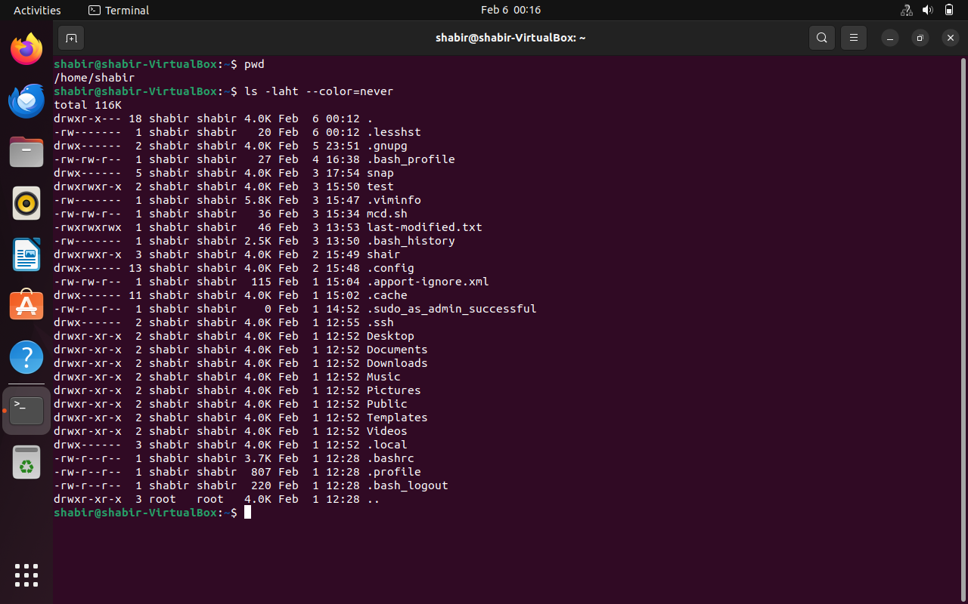

1. **Explanation:**

The objective of the task is achieved by taking help from the documentation of “ls” from the shell. The above output is for the home directory. The –a flag is used to get the list of all files with hidden files in a directory. The –h flag is used for human-readable format. The –t flag is used for the list in recency, the newest file list first. To see the output non–colorized, I used the flag – color=never.